**Using the Cloud Storage**

**By**

**Israel Nolazco**

The following images will showcase the full capabilities of using AWS S3 services. In this document we will explore a remote connection to a virtual machine using a ssh client; which we will then use Linux commands to create folders and files. Then we will connect to an Amazon S3 server. Once, the connection has been establish the folders and files created from the virtual machine will be uploaded to said server and subsequently delete them. The exercise is showcasing the power of Linux command lines.

1. We will start our VM machine and obtain its IP Address. This is a necessary to login with a ssh client portal. As seen in the images below, the IP address is 10.0.1.27

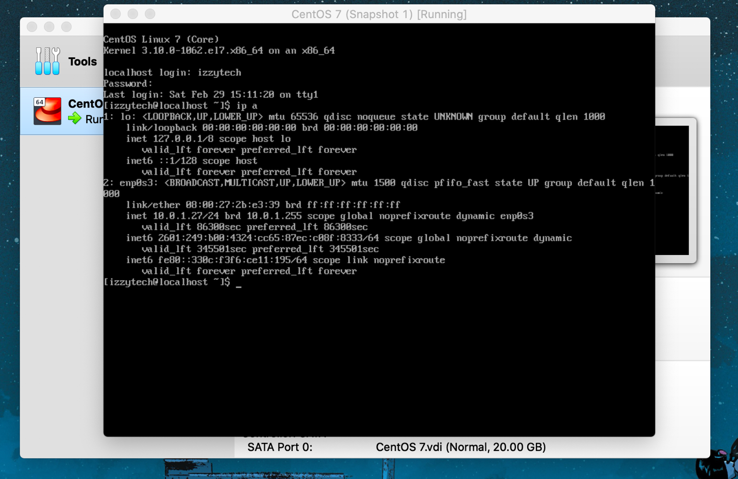

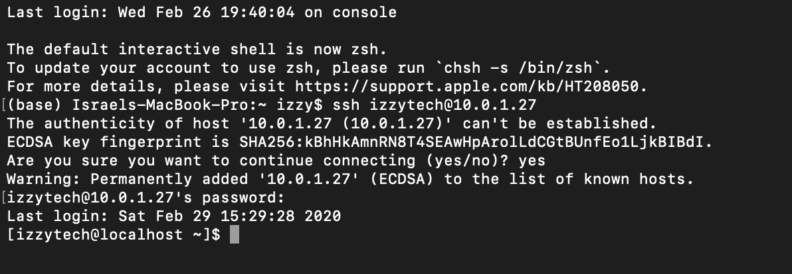

1. After establishing a connection with the VM machine. We will install Python 3 into the VM machine. For this exercise a python script was not use; however, we are installing Python 3 as a tool to use in the future. Additionally, we will also install AWS Command Line Interface (CLI). The CLI will allow us to connect to our AWS S3 machine.

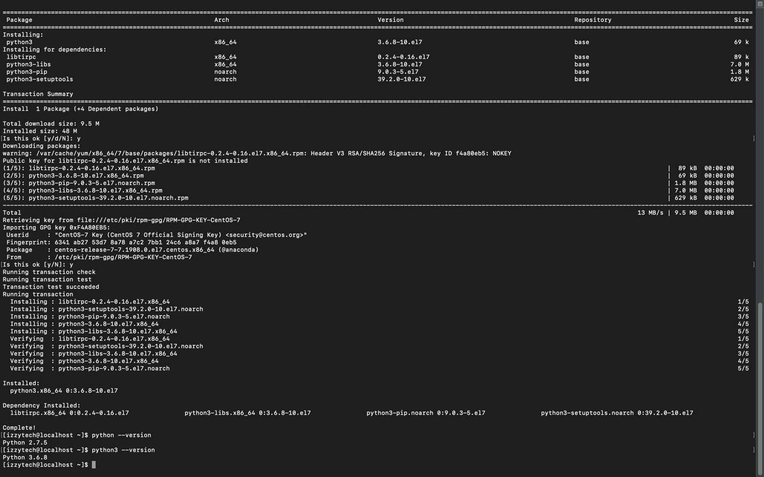

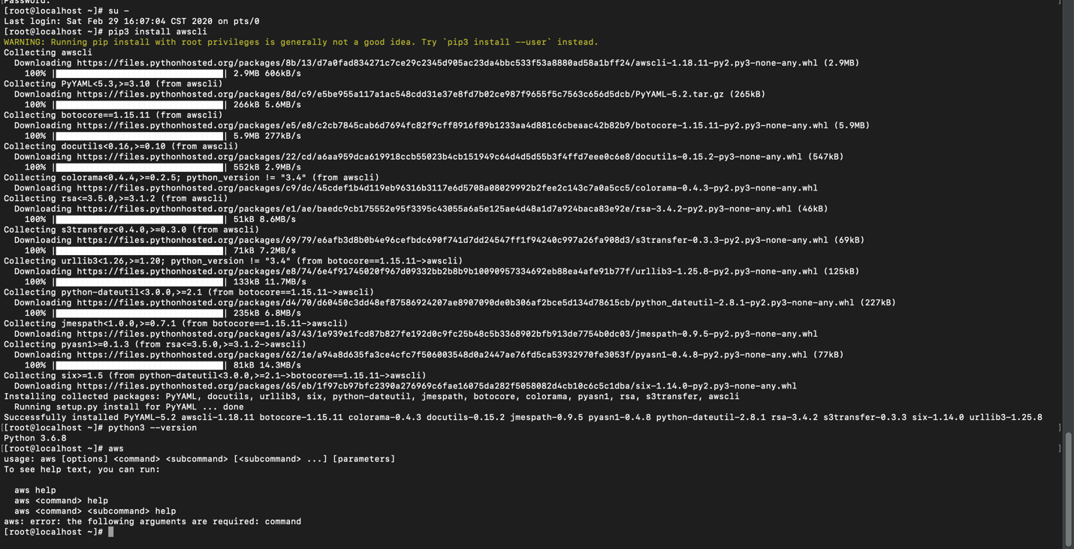

WARNING: Keep in mind that you need a root access to your VM machine in order to install of these applications. Although, this is depending on how the VM machine was initially created. See image below:

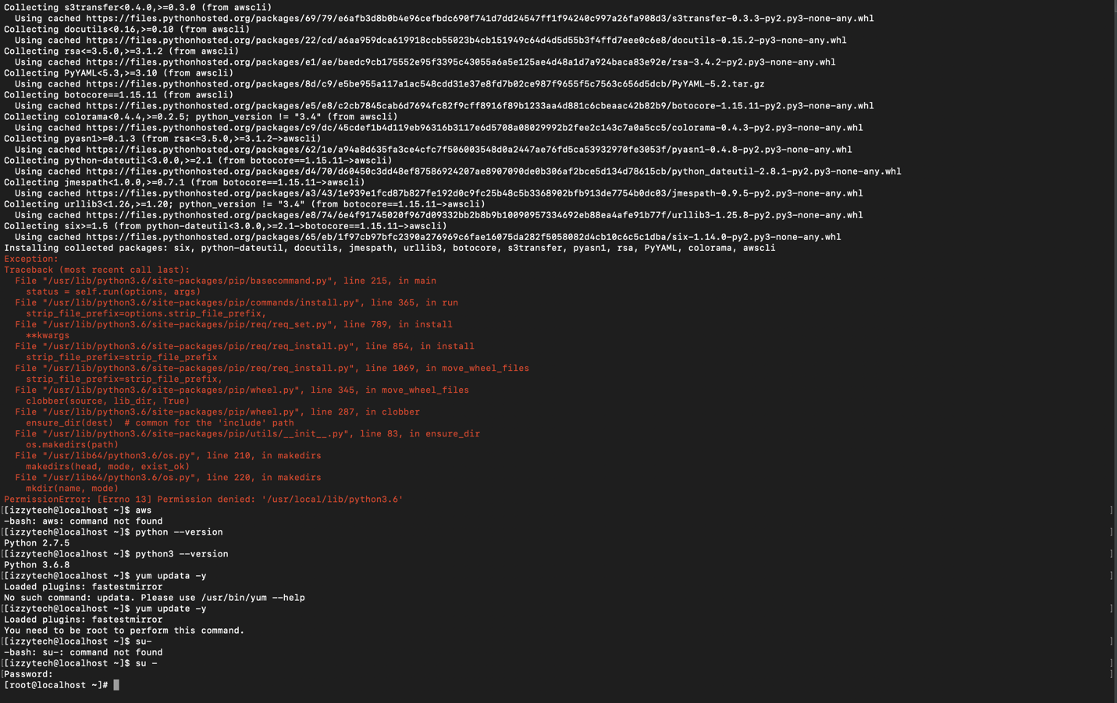

1. Using the AWS’ website a bucket was created. To confirm its existence, we first uploaded a file using the browser and then verify its presence in our CLI.

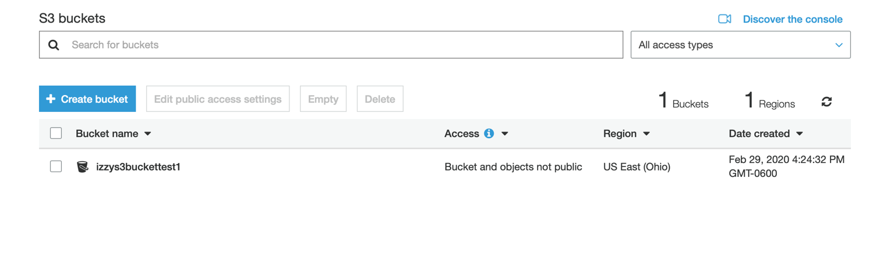

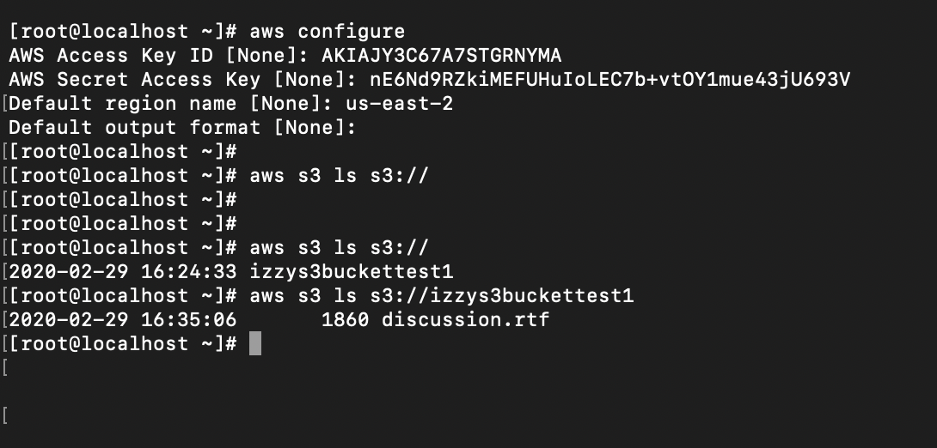



1. Now, we are going to create two folders. “Folder 1” will have three files and “Folder 2” will have five files. The commands “vi” and crucial to create the files.

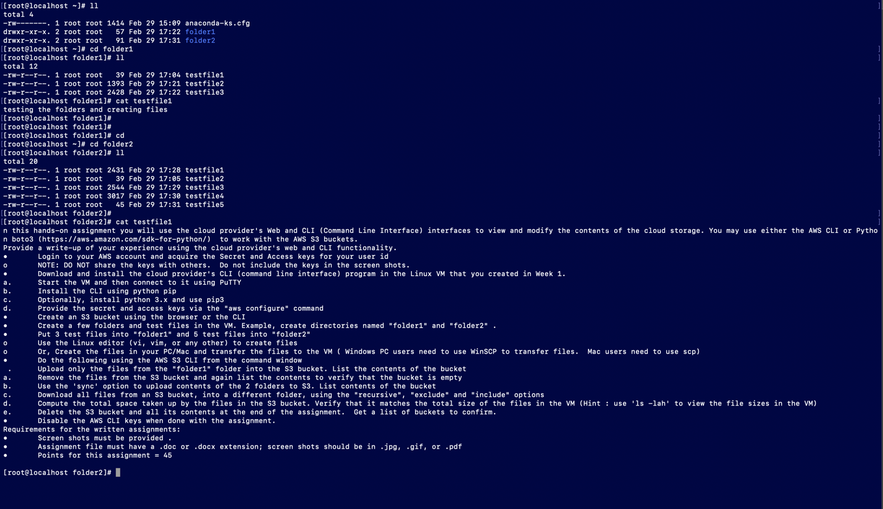

1. To test out our capabilities to our AWS CLI we are going to upload the files from “Folder 1” to the S3 bucket.

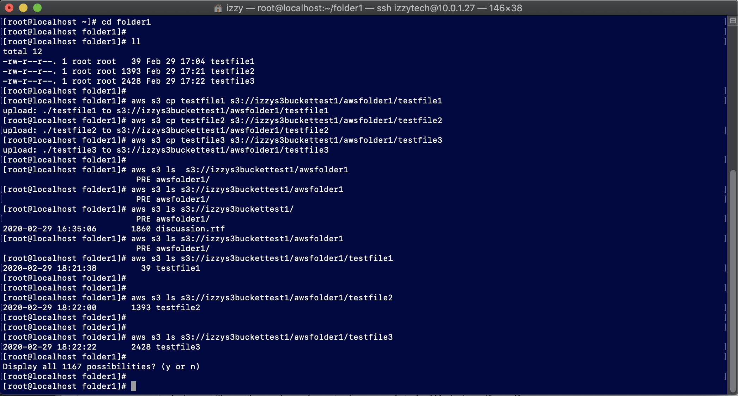

1. Now, let’s see if we can delete the files and verify its deletion.

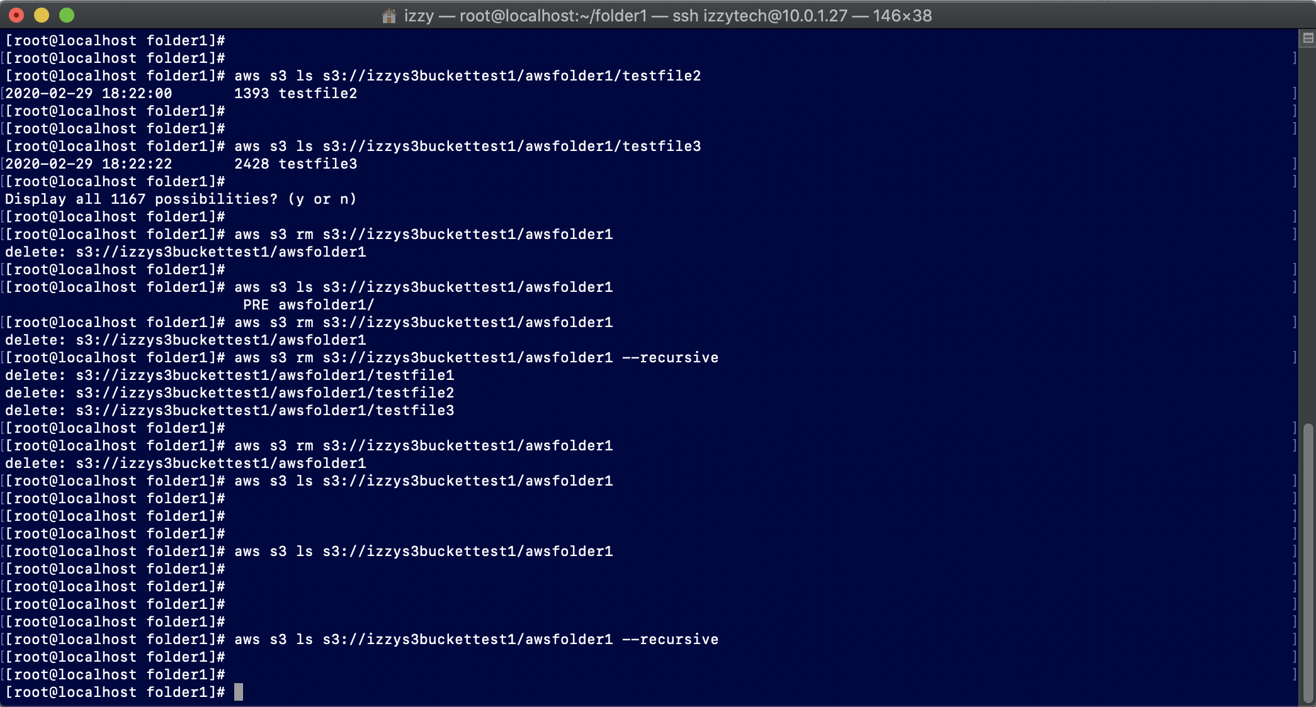

1. Using the “sync” option we are going to upload all of the two folders into our S3 bucket and verify their existence.

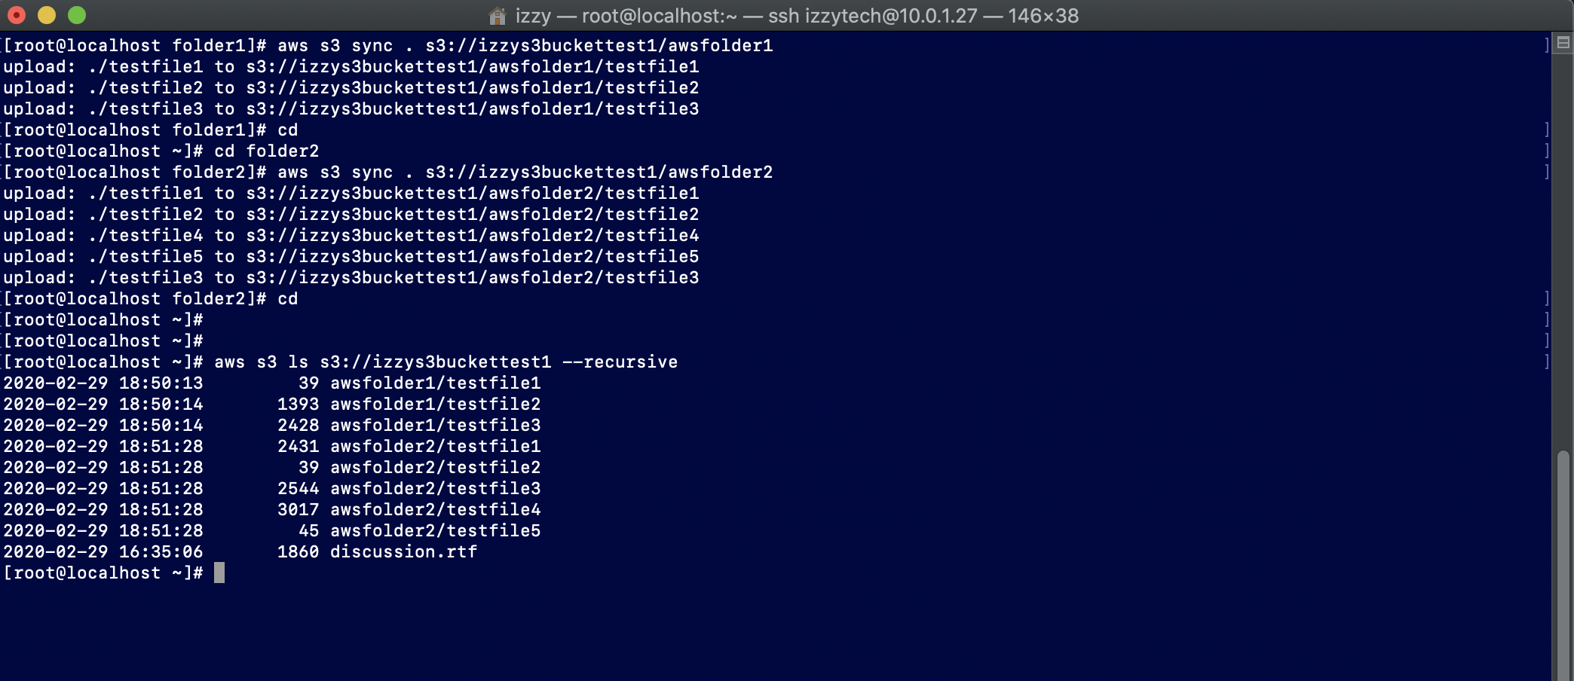

1. Now, using the “sync” option again, we are going to download the files from the S3 bucket into a newly created folder “folder5” in our VM machine. We are going to use the “exclude” and “include” commands. (Note: unless otherwise explained, looks like the “recursive” command is automatic when the “.” is added in our command line)

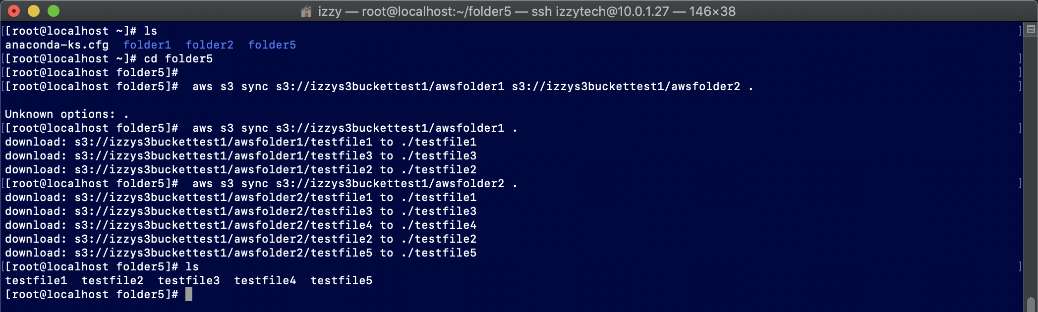

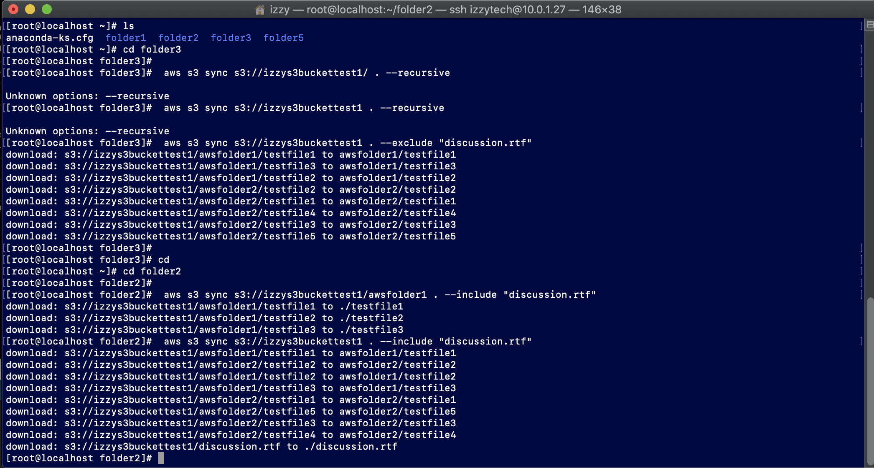

1. Now, we are going to compare the file sizes from the S3 bucket and our VM machine and compare them to make sure the space matches. To do this, a folder named “Total space” was created to run our command.

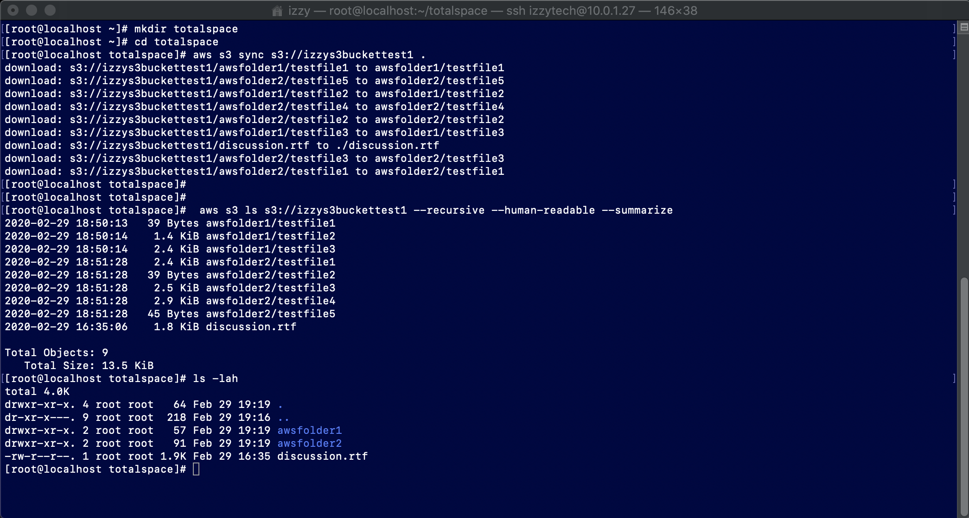

1. Lastly, we are going to delete all of the files from our S3 bucket and then deactivate our CLI key. That will in essence stop the communication to our S3 bucket.

